Response Validation
Response validation is the process of asserting that every aspect of the HTTP response — status code, headers, body content, structure, data types, and values — matches your expectations.
.then() returns a Validatable Response Object that is rich in assertion API Built on top of Hamcrest.

The three layers of response validation
- Status and Headers
Expected status code, headers right content type, caching behaviour.
- Body Content
Does the JSON/XML body contain the right fields with the right values, types, and structure?
- Schema Compliance
Schema Validation

Internal Validation Flow
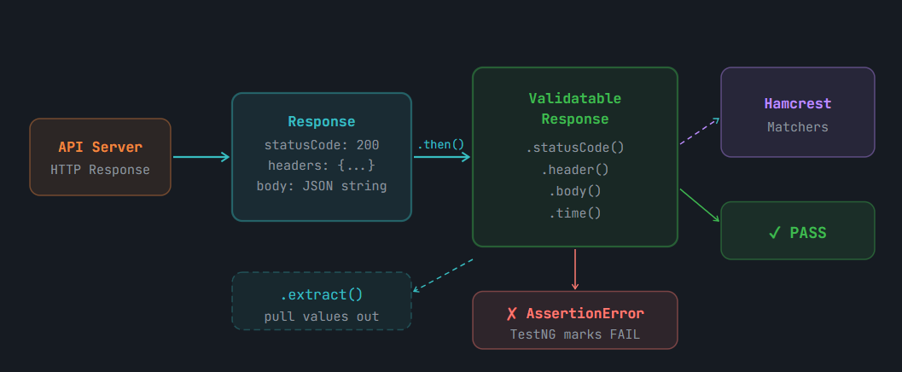
When a Validation Fails – Rest Assured throws java.lang.AssertionError.

Status Code Validation
First thing to validate, tells us whether the server whether the server understood the request at all or not.
// ── Basic equality (most common) ──────────────────────────────
.then().statusCode(200);

// ── Explicit Hamcrest matcher ─────────────────────────────────
.then().statusCode(equalTo(200));

// ── Accept multiple valid codes ───────────────────────────────
.then().statusCode(anyOf(
equalTo(200),
equalTo(201)
));

// ── Assert 2xx family (100-299 range) ─────────────────────────
.then().statusCode(both(greaterThanOrEqualTo(200))
.and(lessThan(300)));

// ── Negative test — expect 404 ────────────────────────────────
given().when().get("/api/users/9999").then().statusCode(404);

// ── Assert NOT a specific code ────────────────────────────────
.then().statusCode(not(equalTo(500)));

// ── statusLine() — full status string ─────────────────────────
.then().statusLine(containsString("OK"));
.then().statusLine(equalTo("HTTP/1.1 200 OK"));

Header Validation
most important header to check is Content-Type — it tells you the format of the body so you know how to parse it.
// ── Exact match ───────────────────────────────────────────────
.then()
.header("Content-Type", "application/json; charset=utf-8");

// ── Contains string (most practical) ─────────────────────────
.then()
.header("Content-Type", containsString("application/json"));

// ── Presence check (header exists, any value) ─────────────────
.then()
.header("Content-Type", notNullValue())
.header("X-Request-ID", notNullValue()); // custom header present

// ── Multiple headers in one then() chain ──────────────────────
.then()
.header("Content-Type", containsString("json"))
.header("Cache-Control", equalTo("no-cache"))
.header("X-RateLimit-Remaining", notNullValue());

// ── Numeric comparison on header value ────────────────────────
// headers() with a Function — convert string to int first
.then()
.header("Content-Length", Integer::parseInt, greaterThan(0));

// ── headers() — assert multiple at once using a Map ───────────
Map<String, String> expectedHeaders = new HashMap<>();
expectedHeaders.put("Content-Type", "application/json; charset=utf-8");
expectedHeaders.put("Server", "cloudflare");

.then().headers(expectedHeaders);

// ── contentType() shorthand ───────────────────────────────────
.then().contentType(ContentType.JSON); // cleaner than header() for CT
.then().contentType(containsString("json")); // with matcher

// ── Extract header value for assertion elsewhere ───────────────
String ct =
given().when().get("/api/users")
.then().extract().header("Content-Type");

Assert.assertTrue(ct.contains("json"), "Wrong content type: " + ct);

Response Time Assertion
Performance is a valid API test, REST Assured can assert on how long the server took to respond, using Hamcrest matchers on the response time in milliseconds.
import java.util.concurrent.TimeUnit;

// ── Assert response under 2000ms (default unit: milliseconds) ─
.then()
.time(lessThan(2000L));

// ── Explicit time unit ────────────────────────────────────────
.then()
.time(lessThan(2L), TimeUnit.SECONDS);

// ── Combined: status + content-type + response time ───────────
.then()
.statusCode(200)
.contentType(ContentType.JSON)
.time(lessThan(3000L));

// ── Extract response time for manual assertions ───────────────
long responseTimeMs =
given().when().get("/api/users")
.then().extract().time();

System.out.println("Response time: " + responseTimeMs + "ms");

Hamcrest
Hamcrest is a Java library of composable "matcher" objects that describe expected conditions.
REST Assured uses Hamcrest extensively — every .body(), .statusCode(), .header(), and .time() call accepts a Hamcrest matcher.

import static org.hamcrest.Matchers.*;
// This one line imports: equalTo, not, is, hasItem, hasItems, hasSize,
// containsString, startsWith, endsWith, notNullValue, nullValue,
// greaterThan, lessThan, greaterThanOrEqualTo, lessThanOrEqualTo,
// empty, emptyIterable, hasKey, hasValue, instanceOf,
// both, either, allOf, anyOf, everyItem, and many more.

How Hamcrest matchers work ?
Each matcher is a predicate — it takes an actual value and returns true or false.
Matchers are also composable — you wrap them inside other matchers (both(), allOf(), not()) to build complex conditions.

Equality Matchers
// equalTo() — strict equality (uses .equals() internally)
.body("data.id", equalTo(2))
.body("data.first_name", equalTo("Janet"))
.body("active", equalTo(true))

// is() — syntactic sugar for equalTo(), reads more naturally
.body("page", is(2)) // same as equalTo(2)
.body("page", is(equalTo(2))) // same again, explicit

// not() — negation wrapper
.body("data.id", not(equalTo(0))) // ID should never be 0
.body("error", not(equalTo("true"))) // error flag should not be true

// ⚠️ Type matters: equalTo(2) vs equalTo("2")
// JSON integers must be matched with int, not String
.body("data.id", equalTo(2)) // ✓ correct — int
.body("data.id", equalTo("2")) // ✗ WRONG — string "2" != int 2

⚠️ Type matching gotcha
Hamcrest's equalTo() is type-sensitive. A JSON integer field {"id": 2} must be matched with equalTo(2) (int literal), not equalTo("2") (String). Mismatched types always fail silently — the matcher returns false without a compilation error. This is the #1 source of confusing test failures in REST Assured.

String Matchers
// containsString() — substring match (case-sensitive)
.body("data.email", containsString("@reqres.in"))
.body("data.email", containsString("janet"))

// startsWith() / endsWith()
.body("data.email", startsWith("janet"))
.body("data.email", endsWith(".in"))

// matchesPattern() — regex match
.body("data.email", matchesPattern("^[a-zA-Z0-9._%+\\-]+@[a-zA-Z0-9.\\-]+\\.[a-zA-Z]{2,}$"))

// containsStringIgnoringCase() — case-insensitive substring
.body("data.first_name", containsStringIgnoringCase("JANET"))

// equalToIgnoringCase()
.body("status", equalToIgnoringCase("OK"))

// emptyString() — field is "" (blank string)
.body("error", emptyString())

// blankString() — field is "" or whitespace only
.body("notes", blankString())

Collection Matchers
When the JSON response contains arrays, you use collection matchers to validate the array's contents, size, and membership.

Sample Code :
// hasSize() — exact size of a list/array
.body("data", hasSize(6)) // array "data" has exactly 6 items
.body("data.size()", equalTo(6)) // GPath alternative — same result

// hasItem() — array contains at least one matching element
.body("data.first_name", hasItem("Janet")) // any user named Janet
.body("data.id", hasItem(7)) // array contains id 7

// hasItems() — array contains ALL listed elements
.body("data.first_name", hasItems("Janet", "Emma"))

// contains() — exact match: same elements in exact order
.body("data.id", contains(7, 8, 9, 10, 11, 12))

// containsInAnyOrder() — same elements, order doesn't matter
.body("data.id", containsInAnyOrder(12, 7, 11, 8, 10, 9))

// empty() — array is empty (zero elements)
.body("errors", empty())

// not(empty()) — array is not empty
.body("data", not(empty()))

// everyItem() — every element in collection matches
.body("data.id", everyItem(greaterThan(0))) // all IDs positive
.body("data.email", everyItem(containsString("@"))) // all emails valid format

// hasKey() / hasValue() — for Map-type JSON objects
.body("support", hasKey("url"))
.body("support", hasValue(containsString("reqres")))

All Types of Matchers:
- Equality Matchers – equalTo({value})
- String Matchers – containsString({value}), startsWith({value}), endsWith({value}), matchesPattern({regex}), containsStringIgnoringCase({value}), equalToIgnoringCase({value}), emptyString(), blankString()
- Collection Matchers – Used to validate content, size of various Collections.
- Numeric Matchers – used to validate numeric values.
- Null/ Existence Matchers – validates values as non null / empty
- Logical Combinator Matchers - Combinators wrapping multiple matchers together for compound matchers.
- Type Matchers - // instanceOf() — checks the Java type of the deserialized value.

📝 JSON type mapping
REST Assured (via Groovy's GPath) maps JSON types to Java types: JSON number → Integer or Float/Double, JSON string → String, JSON boolean → Boolean, JSON array → List, JSON object → Map, JSON null → null.

body()
The .body() method takes a JsonPath expression (a dot-notation path into the JSON) and a Hamcrest matcher. REST Assured evaluates the JsonPath against the response body, extracts the value, and passes it to the matcher for comparison.
// Signature:
// .body(String jsonPath, Matcher matcher, Object... additionalKeyMatcherPairs)

// ── Single field ──────────────────────────────────────────────
.body("data.id", equalTo(2))
.body("data.first_name", equalTo("Janet"))

// ── No path — match the entire body ──────────────────────────
.body(notNullValue()) // body is not empty/null
.body(containsString("Janet")) // raw body string contains "Janet"

// ── Multiple paths in ONE body() call ────────────────────────
.body(
"data.id", equalTo(2),
"data.first_name", equalTo("Janet"),
"data.email", containsString("@reqres.in")
)

// ── Chaining multiple body() calls (equivalent, more readable)
.body("data.id", equalTo(2))
.body("data.first_name", equalTo("Janet"))
.body("data.email", containsString("@reqres.in"))

@Test
public void testGetSingleUserFullValidation() {
given()
.pathParam("id", 2)
.when()
.get("/api/users/{id}")
.then()
// ── Layer 1: Status and metadata ──────────────
.statusCode(200)
.contentType(ContentType.JSON)
.time(lessThan(3000L))

// ── Layer 2: Body field values ─────────────────
.body("data.id", equalTo(2))
.body("data.first_name", equalTo("Janet"))
.body("data.last_name", equalTo("Weaver"))
.body("data.email", containsString("@reqres.in"))
.body("data.avatar", startsWith("https://"))

// ── Layer 3: Types ─────────────────────────────
.body("data.id", instanceOf(Integer.class))
.body("data.first_name", instanceOf(String.class))

// ── Layer 4: Support object ────────────────────
.body("support.url", notNullValue())
.body("support.text", notNullValue());
}

JsonPath
- JsonPath is a query language for JSON, analogous to XPath for XML.
- navigate into a JSON document using a dot-notation path and extract specific values, arrays, or sub-objects.
- EST Assured uses a Groovy-based implementation of JsonPath internally, which also enables GPath expressions — powerful Groovy collection operations.

